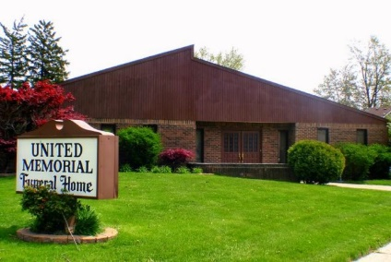
United Memorial Funeral Home
75 Dickinson St.
Mt. Clemens, MI. 48043
(586)463-8800 fax (586)463-8845 Email:admin@unitedmemorialfh.com
www.unitedmemorialfh.com Cynthia Howell, Funeral Director

Funeral arrangements for: Timothy Patrick Smart

Visitation: Sunday, November 15, 2020 2:00 p.m.-6:00 p.m.
United Memorial Funeral Home
75 Dickinson St.
Mt. Clemens, MI. 48043

