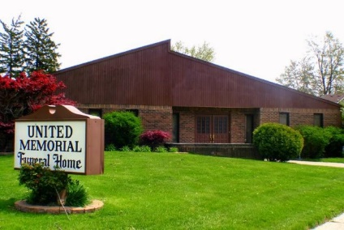
United Memorial Funeral Home
75 Dickinson St.
Mt. Clemens, MI. 48043
(586)463-8800 fax (586)463-8845 Email:admin@unitedmemorialfh.com
www.unitedmemorialfh.com Cynthia Howell, Funeral Director

Funeral arrangements for: Barbara Jean Jett
Visitation: Saturday, February 22, 2020, 10:00 a.m.
United Memorial Funeral Home
75 Dickinson St.
Mt. Clemens, MI. 48043
Family Hour: Saturday, February 22, 2020 11:00 a.m.
United Memorial Funeral Home
75 Dickinson St.
Mt. Clemens, MI. 48043
Funeral: Saturday, February 22, 2020 12:00 Noon
United Memorial Funeral Home
75 Dickinson St.
Mt. Clemens, MI. 48043
Burial: Lincoln Memorial Park Cemetery

