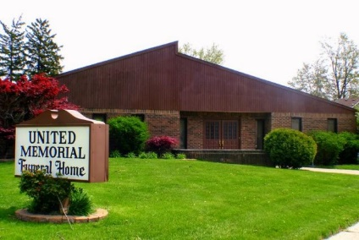
United Memorial Funeral Home
75 Dickinson St.
Mt. Clemens, MI. 48043
(586)463-8800 fax (586)463-8845 Email:admin@unitedmemorialfh.com
www.unitedmemorialfh.com Cynthia Howell, Funeral Director

Funeral arrangements for: Roosevelt Agnew Sr.
Visitation: Friday, August 14, 2020 2:00 p.m. 5:00 p.m.
United Memorial Funeral Home
75 Dickinson St., Mt. Clemens, MI. 48043
Family Hour: Saturday, August 15, 2020 10:00 a.m.
United Memorial Funeral Home
75 Dickinson St., Mt. Clemens, MI. 48043
Funeral: Saturday, August 15, 2020 10:30 a.m.
United Memorial Funeral Home
75 Dickinson St., Mt. Clemens, MI. 48043

Burial: Lincoln Memorial Park Cemetery

