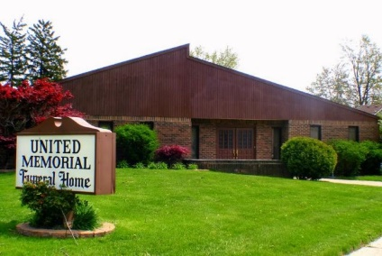
United Memorial Funeral Home
75 Dickinson St.
Mt. Clemens, MI. 48043
(586)463-8800 fax (586)463-8845 Email:admin@unitedmemorialfh.com
www.unitedmemorialfh.com Cynthia Howell, Funeral Director

Funeral arrangements for: Jovonte’ Thurman
Visitation: Thursday, July 2, 2020 2:00 p.m. – 6:00 p.m.
United Memorial Funeral Home
75 Dickinson St.
Mt. Clemens, MI. 48043
Family Hour: Friday, July 3, 2020 10:00 a.m.
United Memorial Funeral Home
75 Dickinson St.
Mt. Clemens, MI. 48043
Funeral: Friday, July 3, 2020 11:00 a.m.
United Memorial Funeral Home
75 Dickinson St.
Mt. Clemens, MI. 48043

Burial: Clinton Grove Cemetery

