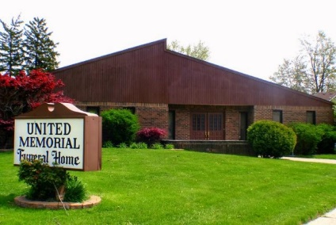
United Memorial Funeral Home
75 Dickinson St.
Mt. Clemens, MI. 48043
(586)463-8800 fax (586)463-8845 Email:admin@unitedmemorialfh.com
www.unitedmemorialfh.com Cynthia Howell, Funeral Director

Funeral arrangements for: James A. Brown Jr.
Visitation: Tuesday, May 26, 2020 2:00-5:00 p.m.
United Memorial Funeral Home
75 Dickinson St.
Mt. Clemens, MI. 48043
Funeral: Wednesday, May 27, 2020 12: Noon
United Memorial Funeral Home
75 Dickinson St.
Mt. Clemens, MI. 48043

