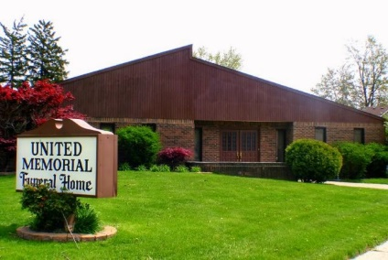
United Memorial Funeral Home
75 Dickinson St.
Mt. Clemens, MI. 48043
(586)463-8800 fax (586)463-8845 Email:admin@unitedmemorialfh.com
www.unitedmemorialfh.com Cynthia Howell, Funeral Director

Funeral arrangements for: Keith A. Tyus
Visitation: Friday, June 26, 2020 1:00 p.m. – 5:00 p.m.
United Memorial Funeral Home
75 Dickinson St.
Mt. Clemens, MI. 48043
Funeral: Friday, June 26, 2020 5:00 p.m.
United Memorial Funeral Home
75 Dickinson St.
Mt. Clemens, MI. 48043
Officating: Pastor John H. Grice

