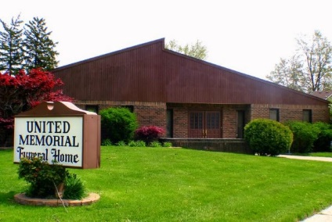
United Memorial Funeral Home
75 Dickinson St.
Mt. Clemens, MI. 48043
(586)463-8800 fax (586)463-8845 Email:admin@unitedmemorialfh.com
www.unitedmemorialfh.com Cynthia Howell, Funeral Director

Funeral arrangements for: Robert Abner

Visitation: Saturday, September 12, 2020 10:00 a.m. -12:00 Noon
United Memorial Funeral Home
75 Dickinson St.
Mt. Clemens, MI. 48043
Burial: Lincoln Memorial Park Cemetery

