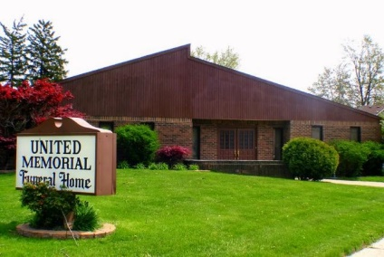
United Memorial Funeral Home
75 Dickinson St.
Mt. Clemens, MI. 48043
(586)463-8800 fax (586)463-8845 Email:admin@unitedmemorialfh.com
www.unitedmemorialfh.com Cynthia Howell, Funeral Directress

Funeral arrangements for: Tyrone Wilson

Visitation: Thursday, July16, 2020 4:00-7:00 p.m.
Tyus Fields Funeral Home
10050 Joy Road @ Wyoming
Detroit, Michigan 48204

