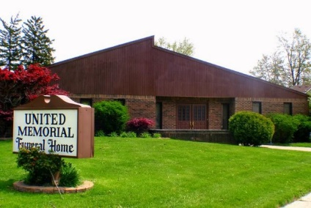
United Memorial Funeral Home
75 Dickinson St.
Mt. Clemens, MI. 48043
(586)463-8800 fax (586)463-8845 Email:admin@unitedmemorialfh.com
www.unitedmemorialfh.com Cynthia Howell, Funeral Director

Funeral arrangements for: Michael Beeman
Family Hour: Friday, June 26, 2020 11:00 a.m.
Greater New Life International Ministry
22457 Quinn Rd.
Clinton Township, MI. 48035
Funeral: Friday, June 26, 2020 12:00 Noon
Greater New Life International Ministry
22457 Quinn Rd.
Clinton Township, MI. 48035
Burial: Great Lakes National Cemetery

