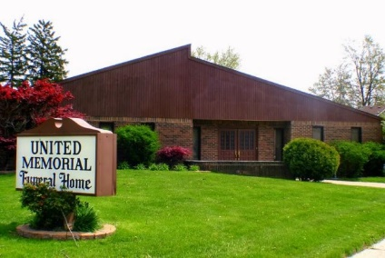
United Memorial Funeral Home
75 Dickinson St.
Mt. Clemens, MI. 48043
(586)463-8800 fax (586)463-8845 Email:admin@unitedmemorialfh.com
www.unitedmemorialfh.com Cynthia Howell, Funeral Director

Funeral arrangements for: Young Woo Song
Visitation: Friday, July 31, 2020 11:00 a.m. 2:00 p.m.
Coats Funeral Home
8909 Dixie Hwy.
Clarkston, MI. 48348
Funeral: Friday, July 31, 2020 2:00 p.m.
Coats Funeral Home
8909 Dixie Hwy.
Clarkston, MI. 48348
Burial: Saturday, August 1, 2020 10:00 a.m.
All Saints Cemetery
4401 Nelsey Rd.
Waterford, MI.

