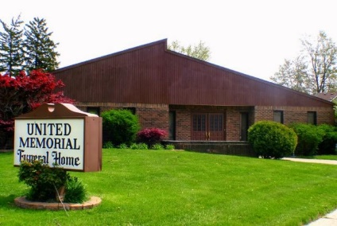
United Memorial Funeral Home
75 Dickinson St.
Mt. Clemens, MI. 48043
(586)463-8800 fax (586)463-8845 Email:admin@unitedmemorialfh.com
www.unitedmemorialfh.com Cynthia Howell, Funeral Director

Funeral arrangements for: Frederick Lee Henry Sr.
Visitation: Friday, March 20, 2020 4:00 p.m.-8:00 p.m.
Stinson Funeral Home
16540 Meyers
Detroit, MI.
Family Hour: Saturday, March 21, 2020 10:00 a.m.
Hartford Memorial
18700 James Couzens Fwy.
Detroit, MI. 48235
Funeral: Saturday, March 21, 2020 11:00 a.m.
Hartford Memorial
18700 James Couzens Fwy.
Detroit, MI. 48235

Burial: Great Lakes National Cemetery

