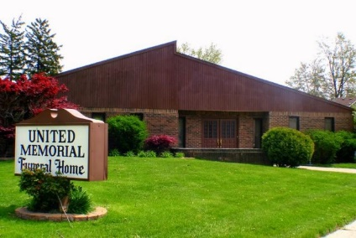
United Memorial Funeral Home
75 Dickinson St.
Mt. Clemens, MI. 48043
(586)463-8800 fax (586)463-8845 Email:admin@unitedmemorialfh.com
www.unitedmemorialfh.com Cynthia Howell, Funeral Director

Funeral arrangements for: Jeffery Lee

Burial: Centennial Cemetery @ 12:00 Noon

