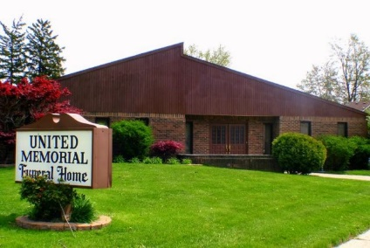
United Memorial Funeral Home
75 Dickinson St.
Mt. Clemens, MI. 48043
(586)463-8800 fax (586)463-8845 Email:admin@unitedmemorialfh.com
www.unitedmemorialfh.com Cynthia Howell, Funeral Director

Funeral arrangements for: Mollie Winfrey-Cribbs
Visitation: Friday, March 13, 2020 2:00 p.m.-8:00 p.m.
United Memorial Funeral Home
75 Dickinson St.
Mt. Clemens, MI. 48043
Family Hour: Saturday, March 14, 2020 11:30 a.m.
Love Life Family Christian Church
17363 Topher Drive
Eastpointe, MI. 48021
Funeral: Saturday, March 14, 2020 12:00 Noon
Love Life Family Christian Church
17363 Topher Drive
Eastpointe, MI. 48021

Officiating: Pastor Kevin W. Lancaster
Burial: Lincoln Memorial Cemetery

