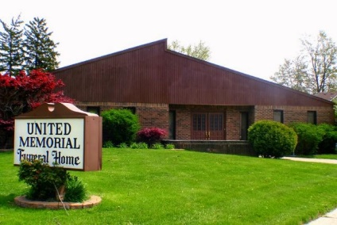
United Memorial Funeral Home
75 Dickinson St.
Mt. Clemens, MI. 48043
(586)463-8800 fax (586)463-8845 Email:admin@unitedmemorialfh.com
www.unitedmemorialfh.com Cynthia Howell, Funeral Director

Funeral arrangements for: Clarence Hannah
Visitation: Wednesday, August 12, 2020 2:00 p.m. 4:00 p.m.
United Memorial Funeral Home
75 Dickinson St., Mt. Clemens, MI. 48043

Funeral: Wednesday, August 12, 2020 4:00 p.m.
United Memorial Funeral Home
75 Dickinson St., Mt. Clemens, MI. 48043

