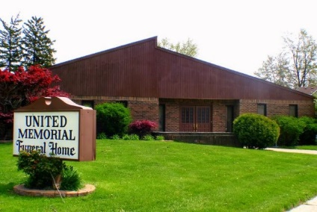
United Memorial Funeral Home
75 Dickinson St.
Mt. Clemens, MI. 48043
(586)463-8800 fax (586)463-8845 Email:admin@unitedmemorialfh.com
www.unitedmemorialfh.com Cynthia Howell, Funeral Director

Funeral arrangements for: William Columbus (Bill) Kincaid Sr.
Visitation: Friday, September 4, 2020 1:00 p.m. – 8:00 p.m.
Greater New Hope Missionary Baptist Church
58527 Delanie St.
New Haven, MI. 48048
Family Hour: Saturday, September 5, 2020 10:00 a.m.
Greater New Hope Missionary Baptist Church
58527 Delanie St.
New Haven, MI. 48048
Funeral: Saturday, September 5, 2020 11:00 a.m.
Greater New Hope Missionary Baptist Church
58527 Delanie St.
New Haven, MI. 48048
Burial: Centennial Cemetery

