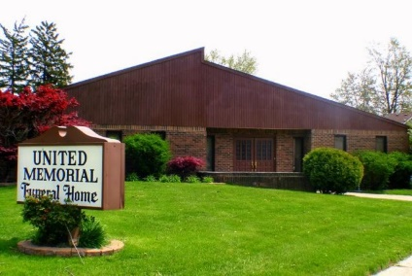
United Memorial Funeral Home
75 Dickinson St.
Mt. Clemens, MI. 48043
(586)463-8800 fax (586)463-8845 Email:admin@unitedmemorialfh.com
www.unitedmemorialfh.com Cynthia Howell, Funeral Director

Funeral arrangements for: April McMillian
Visitation: Sunday, August 9, 2020 1:00 p.m. 5:00 p.m.
United Memorial Funeral Home
75 Dickinson St., Mt. Clemens, MI. 48043
Family Hour: Monday, August 10, 2020 10:30 a.m.
King of Kings International Church
6375 Inkster Rd.
Taylor, MI. 48180
Funeral: Monday, August 10, 2020 11:00 a.m.
King of Kings Church
6375 Inkster Rd.
Taylor, MI. 48180
Burial: Lincoln Memorial Park Cemetery

